Guide to Submitting a Full Paper on RILEM Week 2025 Conference
Step 1: Access the Submission Platform
- Open your web browser and navigate to https://rilemweek2025.sciencesconf.org.
- Click on the "Login" button in the top-right corner of the homepage.
- If you already have an account on SciencesConf, enter your credentials and log in.
- If you do not have an account, click "Create an account", complete the registration form, and activate your account via the confirmation email.
Step 2: My space - click My submissions
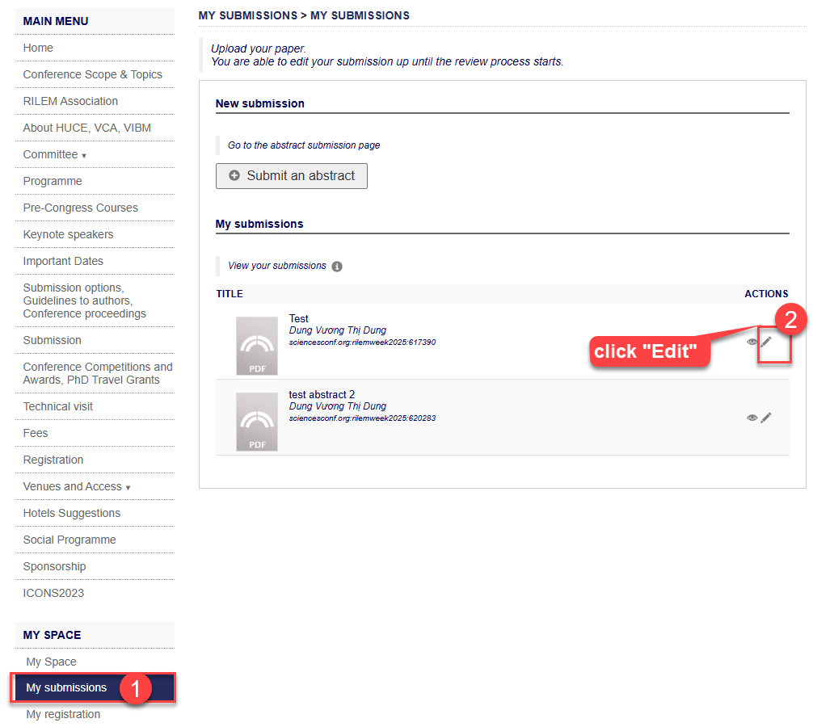
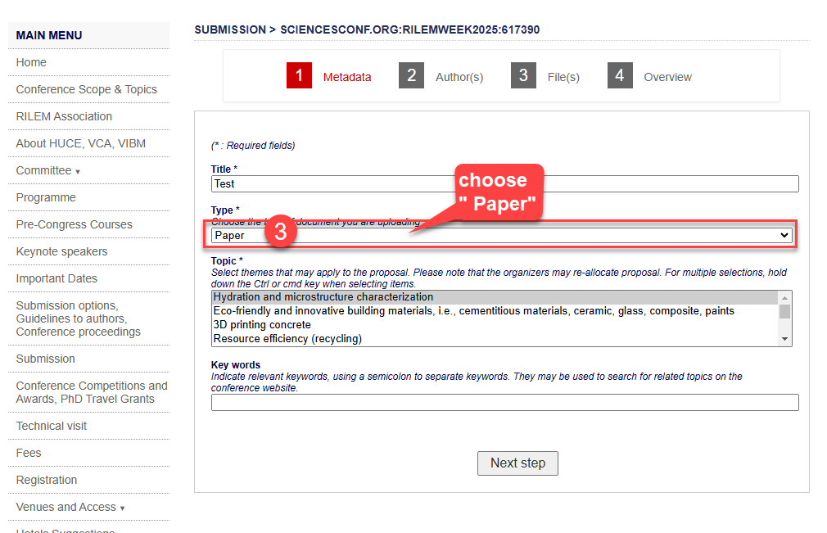
continue with the submission steps…
Contact Support
If you experience any issues, please contact the RILEM Week 2025 organizing committee at rilemweek2025@huce.edu.vn

